4th European Fullcontact Karate Camp
Invitation en guidance

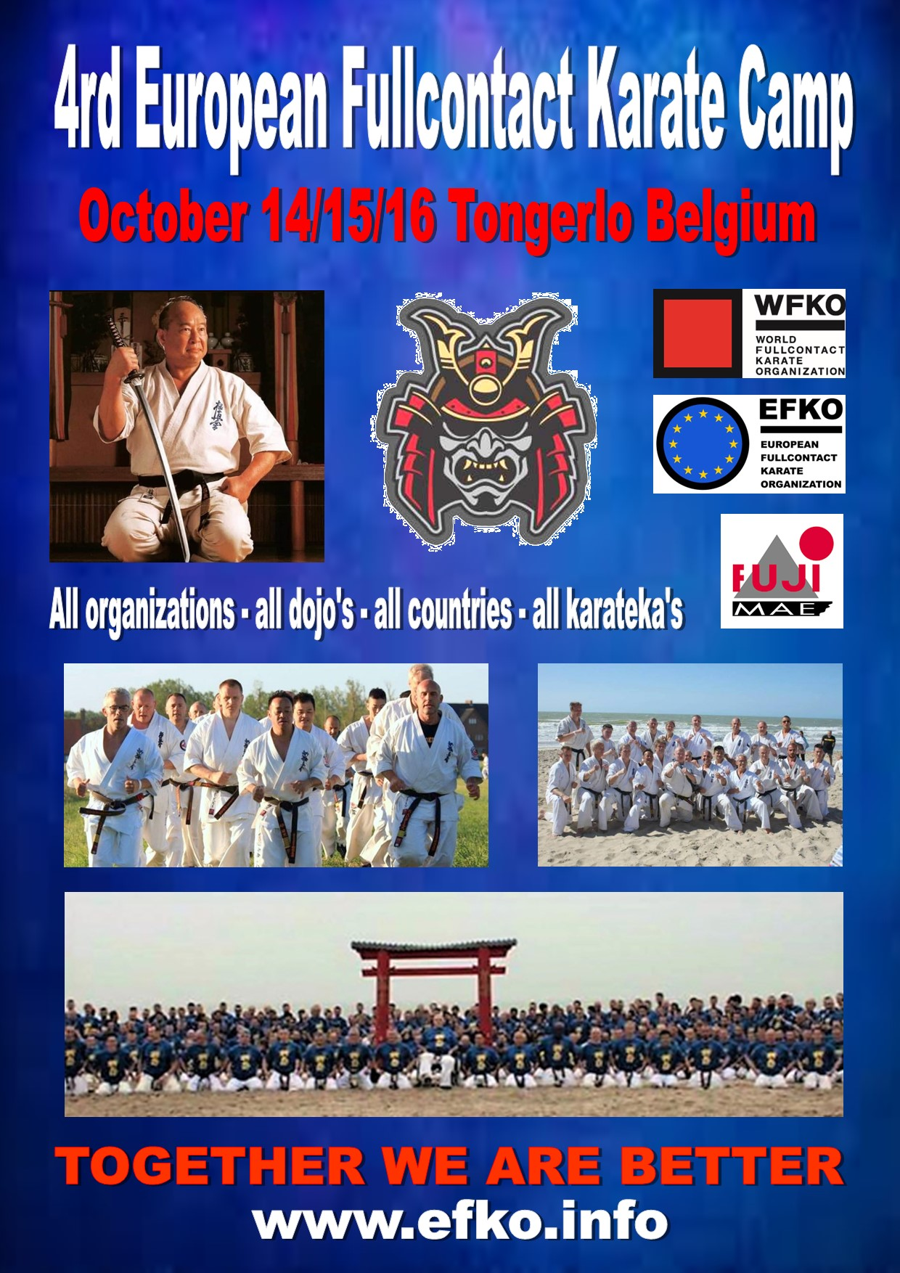

4th European Fullcontact Karate camp 2022

Dear Fullcontact Karate Friends,
We’re very happy to invite you to the 4th European Fullcontact Karate Camp 2022. Participants from all organizations are welcome, starting from the age of 12. The camp is a collaboration between all Fullcontact Karate Organizations and styles to give our students the chance to train with eachother and to enjoy the power of unification, osu!

Instructors
Shihan Koen Scharrenberg | President of the EKO Holland
Shihan David Picktall | President of IFK – world champion - UK
Shihan Paul Lorist | President of KWF Holland
Sensei Jonathan Tineo | Independent - World Champion – Spain
Sensei Lukas Kubilius | WKO – world Champion – Lithuania
Sensei Jan Soukup | Kyokushinkai kan – CFKO - Czech
Shihan Remigiusz Karpinsky | WKO Poland
Shihan Jozef Stefanovics | WKO Hungary
Shihan Jan Bulow | WKO Denmark
Shihan Dai Nicu Dascalu | Ashihara Niko Romania – World champion
Sensei Cristian Boldut | WKO Romania
Sensei Levan Tsintadze | WKO Georgia
Sensei Emma Markwell | IFK - World champion - UK
Shihan Semmy Schilt | World champion Karate and K1
……………………………….. | Japan
……………………………….. | Japan

Note for shihans: All shihans will stand in front and they have a free role, you can help with teaching, join the training or walk around to observe.
Time and place
The 4th EFKC will take place at Sporta Spot Kempen, Geneinde 2, 2260 Westerlo
E. kempen@sportaspots.be
W. www.sportaspots.be
The camp starts at Friday October 14th (check-in between 16.00hr. and 19.30hr.) First training start at 20.00hr. The camp ends on Sunday October 16th (around 13:30) after the lunch, which is included.
Accommodation (300 places available) European Fullcontact Village
Sport spot is a vacation resort with different possibilities. Everybody can choose one of the choices, but we handle the principle “first register, first serve” basis!
In all accommodations the following things are included: All meals from Friday evening till Sunday lunch, two nights in chosen accommodation, towels and blankets, a great EFKO – warrior T-shirt, all trainings from top instructors and a never give up Sayonara party.
Prices
Bungalows 3 or 4 beds
Early Booking: 195€
After July 20th : 210€
Bungalows 5 + beds
Early Booking: 185€
After July 20th : 200€

If you want more luxury and book a hotel in the neighborhood the price for the camp is:

Early Booking: 150€
After July 20th : 165€
Don’t forget to bring …
2 dogi - Shin/hand protection - Track suit Running shoes (outside) – Towels and Swimming gear - Sun protection, be prepared for the weather (cold / hot)

Never give up Sayonara Party with BBQ
Those who whore already on the sayonara party know that the Belgians are a little bit crazy and that the party’s always are big fun. Saturday evening we start at 21.00hr. PARTY outfit Casual

Organizer& legal considerations
The 4th European Fullcontact Karate Camp 2022 is organized on behalf of the European Fullcontact Karate Organization with help of the Belgian Karate Organization Shinkyokushin All info or questions can be send to Sensei Michiel Vleminckx who will be glad to answer them: michielvleminckx@hotmail.com
Participants have to organize their own insurance. The organizer will reject any responsibility in case of injury or theft. Participants under the age of sixteen should obtain “acceptance for participation” from their parents or legal guardian. Please have this with you at the beginning of the camp ,or send this in advance to michielvleminckx@hotmail.com

Registration:
The website for information and reservation: www.efko.info
Click on Reservation and fill in the form. Also the payment will go true the website. The registration will only be done if we got the total payment.
Important! A cancelation has to be informed 30 days before the Camp. After this date till September 13th the cancel prices is 70€ After this date you will not be able to charge your money back. Due to obligations to the Organizer, these rules will be strictly handled.
Early booking will end on July 20th, so be aware that the payments has to be done before that date.
Be aware of the fact that we will handle the principle first pay, first serve! Please fill in your T-shirt size correctly.

Dear friends, let’s make a unforgettable camp of unification for all Fullcontact Karate groups. Let us train together, sweat together, have fun together, share our passion together, learn from each other, feel the friendship from each other, have a big party together………
Fullcontact Karate is a live and we gone proof the power of “Together we are Better”
We hope to see you all in our Fullcontact karate Village
Big osu!
Koen Spitaels Shihan
European Fullcontact Karate Organization
